**ARTIFICIAL INTELLIGENCE**



**School of Computer science engineering**

**Subject code**- INT- 404

**Project name** – Disease prediction Using AI

**Section –** K18FR **Group**-01

**Submitted to** -Ishatpreet Kaur mam

Submitted by

|  |  |  |  |
| --- | --- | --- | --- |
| **Reg.no** | **Roll no.** | **Name** | **Marks** |
| 11806097 | RK18FRA17 | Vadlakonda Srinilaya Reddy |  |
| 11806114 | RK18FRA18 | RAM PRAKASH |  |
| 11804800 | RK18FRA19 | Nikhil pathak |  |
| 11805046 | RK18FRA20 | VISHAL KUMAR RAI |  |

**1.Introduction-**

Now a days AI has become the part of our life and they are improving day by day. Artificial intelligence is every

Where like AI cameras to make the persons look better

Than real. AI are used in many fields like in agriculture field to keep the track of quality of seeds and plants, crops. AI is also used in cars for auto driving as well as in

Medical field to diagnose and treat the person like the AI will check the pulse rate of patient or person, can also check the temperature of the body, Artificial intelligence is used to diagnose disease symptoms like cancer’s Symptoms, Asthma’s Symptoms. In this we will use the Artificial intelligence to predict disease like COVID-19, Asthma and FLU etc. In which we will ask some question like symptoms and question related to that symptoms like if person having problem in breathing then we will ask that do you have Asthma. And like to rate their problem in breathing between 0 to 10. The program will collect all the data in the form of

Answers and will predict in three stages first is high chances of having that disease in this state the person needs to visit the nearby health center and In second which is Medium chances in this state says that the person body is showing the similar symptoms but it can be or cannot be related to that disease in this state person needs to relax at home and after a two or three days need to visit the doctor. Third state is Low chances in this that symptoms are not familiar with that disease and you need not to worry.

**2.Objective –**  Main objective of making this AI is to diagnose the people and make them aware about the disease symptoms and to

Give them some suggestions that how to tackle that situation. Their will be only two condition either Bad/Critical or Good. like if they are in a critical or bad condition then they urgently need medication or In Good condition that means that their body symptoms either not matching with the symptoms of disease or Less symptoms. And after confirming the situation the suggestion will be given to the user.

**3.Application –**  The Application of Artificial intelligence is the use of it in Medical field or Medication and the application of these AI is to diagnose the patient by asking them Questions about their current health condition or the Symptom’s related to that disease and Another application is to give then suggestion or advice that how to tackle this kind of situations and if it will not under control then it will suggest that the person needs urgent medical help. If it will be under control, then it will suggest some medication.

**4.Algorithm –**

Create two list and 1 to print the disease name which will be diagnosed and then it will take input to choose like 1 for corona ,2 for Asthma ,3 for ORVI disease related to respiratory problem ,4 for Meningitis and 5 for Bronchitis.

After choosing the disease symptoms related to that disease will be shown and then a question will be asked that if you have observed this symptom in your body then press 1 if no then 0.

If(Choice==1):

Print(“Your answer is yes”)

Elif(Choice==0):

Print(“your answer is no”)

Else:

Print(“Please enter yes or no”)

Then it will ask questions related to symptoms of that disease if the user will be having it or observed it in his body. If the answer is not related like other than yes or no then it will show please enter yes or no.

For corona

Sym=int(input(“You have cough problem”)) //if yes then 1 if no then 0.

Ans0=int(input("Have you travelled on through outer country recently :"))  
if(Ans0==1):  
 print("Your answer is yes")  
elif(Ans0==0):  
 print("Your answer is No")  
else:  
 print("please enter yes or no")  
 exit()

Then it will calculate the total yes and no if the number of yes will be or the body is showing more symptoms related to that disease then it will say according to that like it will calculate the total number of yes if the questions asked is 10 then it will be like

If(10>=yes=>5):

Print(“You are in bad condition and you urgently need some medical help and medication.”)

If(Yes=>4):

Print(“You are in safe condition and your body is showing less symptoms related to that disease symptoms”)

Same for all.

**5.Constraints –** 1. If input is not related to that disease number, then it will show that” please enter a valid number” and then it will some symptoms related to that disease and it will ask that do you any symptoms if yes then press 1 if no then 0. Like

Choice=int(input(“Enter yes if you have symptoms related to that symptoms if not then no ”)

If(Choice==1):

Print(“your answer is yes”)

Elif(Choice==0):

Print(“Your answer is no”)

Else:

Print(“please enter a valid input”)

then in symptoms it will ask that do have this problem like-

Ans0=int(input("Have you travelled on through outer country recently :"))  
if the answer will be other like –

if(Ans0==1):  
 print("Your answer is yes")  
elif(Ans0==0):  
 print("Your answer is No")  
else:  
 print("please enter yes or no")  
 exit()

then if no symptoms will be match then it will some suggestion related by calculating the total number of yes. Like number of questions asked is 10 then it will be like

If(10<=yes>=5):

Print(“you are bad condition”)

Elif(yes<=4):

Print(“Your body is showing less symptoms related to that disease.”)

**6.Code Snippet-**

lst=['Corona','Asthma','ORVI','Meningitis','Bronchitis']  
lst1=[1,2,3,4,5]  
for i in range(0,5):  
 print(lst1[i],lst[i])  
Dis=int(input("Enter the number you want to get diagnosed otherwise zero to exit :"))  
if(Dis==1):  
 print("Corona")  
 print("The Symptoms of this disease is high fever with dry cough and problem in breathing \n And it shows its symptoms within a week")  
 Choice=int(input("Enter if you have ""observed this symptoms then 1 if not then 2 :"))  
 if(Choice==1):  
 print("Your answer is yes")  
 print("Enter 1 for yes and 0 for no")  
 Ans0=int(input("Have you travelled on through outer country recently :"))  
 if(Ans0==1):  
 print("Your answer is yes")  
 elif(Ans0==0):  
 print("Your answer is No")  
 else:  
 print("please enter yes or no")  
 exit()  
  
 Ans01=int(input("Have you came in a contact with a person having problem in breathing and fever and cough :"))  
 if(Ans01==1):  
 print("Your answer is yes")  
 elif(Ans01==0):  
 print("Your answer is No")  
 else:  
 print("please enter yes or no")  
 Ans02=int(input("Have you came in contact with confirmed corona Virus patient :"))  
 if(Ans02==1):  
 print("Your answer is yes")  
 elif(Ans02==0):  
 print("Your answer is No")  
 else:  
 print("please enter yes or no")  
 Tot=(Ans0+Ans01+Ans02)/10  
 if(Tot==0.3):  
 print(" ")  
 elif(Tot==0.2):  
 print(" ")  
 Ans = int(input("Do you have any coughing problem :"))  
 if(Ans==1):  
 print("Your answer is yes")  
 sym1 = int(input("On scale of 1 to 10 rate Coughing :"))  
 if(sym1>=11):  
 print("Only rate from 1 to 10")  
 Ans3=int(input("Do You have any problem like Asthma :"))  
 if (Ans3 == 1):  
 print("Your answer is yes")  
 elif (Ans3 == 0):  
 print("Your answer is No")  
 else:  
 print("please enter yes or no")  
 exit()  
 t=sym1  
 Ans1 = int(input("Do you have fever :"))  
 if(Ans1==1):  
 print("Your answer is Yes")  
 Sym2=int(input("On scale of 1 to 10 rate Fever :"))  
 if(Sym2>=11):  
 print("Only rate from 1 to 10")  
 t=t+Sym2  
 Ans4=int(input("Are you facing problem in breathing :"))  
 if (Ans4 == 1):  
 print("Your answer is yes")  
 elif (Ans4 == 0):  
 print("Your answer is No")  
 else:  
 print("please enter yes or no")  
 exit()  
 if(Ans4==1):  
 print("Your answer is yes")  
 Sym3=int(input("On Scale of 1 to 10 rate your problem in breathing :"))  
 if(Sym3>=11):  
 print("Only rate from 1 to 10")  
 Ans2 = int(input("Do you have any breathing problem ? then yes if not then no :"))  
 if(Ans2==1):  
 lst2=['Athama','Emphysema','Pneumonia']  
 for i in range(0,3):  
 print(lst2[i])  
 A=int(input("Enter the number"))  
 if(A==1):  
 print("Asthama")  
 elif(A==2):  
 print("Emphysema")  
 elif(A==3):  
 print("penumonia")  
 t=t+Sym3+Tot  
 if(25.1<=t<=30.3):  
 print("High chances")  
 print("Sugestion \nYou are in immediately need of visiting the nearest Corona help center And Cover your mouth,tell you family members to ")  
 print("Stay away from you and avoid physical contact and maintain at least 1 meter distance Wash your hand after every tweenty minute")  
 elif(24.3<=t<=19.1) :  
 print("Medium chances")  
 print("Sugestion \nYou need to visit the nearest Corona help center for test and confirmation And Cover your mouth")  
 print("Stay away from others and avoid physical contact and maintain at least 1 meter distance Wash your hand \nafter every tweenty minute and stay at home")  
 elif(18.2>=t>=0.3):  
 print("Low Chances")  
 print("Sugestion \nYou need to Cover your mouth Stay away from others and avoid physical contact and maintain at ")  
 print(" least 1 meter distance Wash your hand after every tweenty minute and stay at home.")  
 elif(Choice==2):  
 print("Thanks for using")  
 exit()  
 else:  
 Print("Wrong input")  
 exit()  
  
if(Dis==2):  
 print("Enter 1 for yes and 0 for no ")  
 print("Asthma")  
 print("Symptoms include difficulty in breathing ,chest pain ,cough and wheezing .the symptoms may sometime flare up")  
 Choice = int(input("Enter if you have ""observed this symptoms then 1 if not then 2 :"))  
 if (Choice == 1):  
 print("Your answer is yes")  
 sym1=int(input("Do you cough at night or all the time:"))  
 if(sym1==1):  
 print("Your answer is yes")  
 elif(sym1==0):  
 print("Your answer is No")  
 else:  
 print("please enter yes or no")  
 exit()  
 sym2=int(input("Do you experience shortness in breathing or rapid breathing: "))  
 if(sym2==1):  
 print("Your answer is yes")  
 elif(sym2==0):  
 print("Your answer is No")  
 else:  
 print("please enter yes or no")  
 exit()  
  
 sym3=int(input("Do you chest pressure ,flare ,Anxiety : "))  
 if(sym3==1):  
 print("Your answer is yes")  
 elif(sym3==0):  
 print("Your answer is No")  
 else:  
 print("please enter yes or no")  
 exit()  
  
 sym4=int(input("Does your heart rate suddenly increases and you feel irritation in throat: "))  
 if(sym4==1):  
 print("Your answer is yes")  
 elif(sym4==0):  
 print("Your answer is No")  
 else:  
 print("please enter yes or no")  
 exit()  
 t=sym1+sym2+sym3+sym4  
 print(t)  
 if(t>=4):  
 print("suggestion \nyou are in critcial condition and you need treatment")  
 print("teartment\nAsthma can be managed with resuce inhaler to treat symptoms (salbutamol) and controller inhaler that \nprevents symptoms(steroids)")  
 if(t<=2):  
 print("suggestion \nyour body is showing the less symptoms of asthma you just need a need a controller inhaler which will prevent you from asthma attack")  
 elif(Choice == 2):  
 print("Thanks for using")  
 exit()  
 else:  
 Print("Wrong input")  
  
elif(Dis==3):  
 print("ORVI")  
 print("Symptoms ussually resolve within two weeks and include a scratchy or sore throat,sneezing,stuffy\nnose and cough")  
 Choice = int(input("Enter if you have ""observed this symptoms then 1 if not then 2 :"))  
 if (Choice == 1):  
 print("your answer is Yes")  
 print("Enter 1 for yes and 0 for no")  
 sym1 = int(input("Do you feel pain in the sinuses:"))  
 if (sym1 == 1):  
 print("Your answer is yes")  
 elif (sym1 == 0):  
 print("Your answer is No")  
 else:  
 print("please enter yes or no")  
 exit()  
 sym2 = int(input("have you lost the experience of smell and experiece congestion: "))  
 if (sym2 == 1):  
 print("Your answer is yes")  
 elif (sym2 == 0):  
 print("Your answer is No")  
 else:  
 print("please enter yes or no")  
 exit()  
 sym3 = int(input("Does your whole body is in fever and restless: "))  
 if (sym3 == 1):  
 print("Your answer is yes")  
 elif (sym3 == 0):  
 print("Your answer is No")  
 else:  
 print("please enter yes or no")  
 exit()  
 sym4 = int(input("Do you feel irritation in throat and soareness : "))  
 if (sym4 == 1):  
 print("Your answer is yes")  
 elif (sym4 == 0):  
 print("Your answer is No")  
 else:  
 print("please enter yes or no")  
 exit()  
 sym5=int(input("DO you have cough and headche and swollen lymph nodes: "))  
 if (sym5 == 1):  
 print("Your answer is yes")  
 elif (sym5 == 0):  
 print("Your answer is No")  
 else:  
 print("please enter yes or no")  
 exit()  
 t = sym1 + sym2 + sym3 + sym4+sym5  
 print(t)  
 if (t >= 5):  
 print("suggestion \nyou are in bad condition and you need treatment")  
 print(  
 "teartment\nTreatment includes rest and medication to relieve symptoms. and medicines are couh medicine ,Nonsteroidal anti-inflammatory drug,Analgesic\nand dietary Supplemant ")  
 if (t <= 3):  
 print("suggestion \nyour body is showing the less symptoms of asthma you just need rest and normal mediction to relief")  
 elif(Choice == 2):  
 print("Your answer is no")  
 print("Thanks for using")  
 exit()  
 else:  
 Print("Wrong input")  
 exit()  
elif(Dis==4):  
 print("Meningitis")  
 print("symptoms include headche,fever,stiff neck")  
 Choice = int(input("Enter if you have ""observed this symptoms then 1 if not then 2 :"))  
 if (Choice == 1):  
 print("your answer is Yes")  
 print("Enter 1 for yes and 0 no")  
 sym1 = int(input("Do you feel pain in the back:"))  
 if (sym1 == 1):  
 print("Your answer is yes")  
 Ans=int(input("Rate your pain in back from 1 to 10"))  
 if(Ans>=11):  
 print("Only rate from 1 to 10")  
 exit()  
 elif (sym1 == 0):  
 print("Your answer is No")  
 else:  
 print("please enter yes or no")  
 sym2 = int(input("Do you have fever and you have lost your appetite and you are shivering: "))  
 if (sym2 == 1):  
 print("Your answer is yes")  
 Ans0=int(input("Rate your fever from 1 to 10"))  
 if(Ans0>=11):  
 print("Only rate from 1 to 10")  
 exit()  
 elif (sym2 == 0):  
 print("Your answer is No")  
 else:  
 print("please enter yes or no")  
  
 sym3 = int(input("Are you vomiting and feeling nausea: "))  
 if (sym3 == 1):  
 print("Your answer is yes")  
 elif (sym3 == 0):  
 print("Your answer is No")  
 else:  
 print("please enter yes or no")  
 exit()  
 sym4 = int(input("Is you skin has blotchy rashes or Red rashes : "))  
 if (sym4 == 1):  
 print("Your answer is yes")  
 elif (sym4 == 0):  
 print("Your answer is No")  
 else:  
 print("please enter yes or no")  
 exit()  
 sym5 = int(input("Does your heart beat has become fast: "))  
 if (sym5 == 1):  
 print("Your answer is yes")  
 elif (sym5 == 0):  
 print("Your answer is No")  
 else:  
 print("please enter yes or no")  
 exit()  
 sym6=int(input("Do you feel sleepiness all the time: "))  
 if(sym6==1):  
 print("Your answer is Yes")  
 elif(sym6==0):  
 print("your answer is No")  
 else:  
 print("Please enter yes or no ")  
 exit()  
 t = sym1 + sym2 + sym3 + sym4 + sym5+sym6  
 print(t)  
 if (t >= 6):  
 print("suggestion \nyou are in Bad condition and you need treatment")  
 print("teartment\nDepending on the cause, Meninfitis may get better on its own or it can be life threatening require urgent \nAnti-biotic treatment")  
 print("teatment\nAnti-Biotic, Steroid and penicilin and oxyen therapy and Hospitalization")  
  
 if (t <= 3):  
 print("suggestion \nyour body is showing the less symptoms of meningitis If you still have doubt then you can take penincilin.")  
 elif(Choice == 2):  
 print("Thanks for using")  
 exit()  
 else:  
 Print("Wrong input")  
 exit()  
elif(Dis==5):  
 print("Bronchitis")  
 print("Symptoms of bronchitis include coughing up thickened mucus and shortness of breath.")  
 Choice=int(input("Enter 1 if yes otherwise 2 for no: "))  
 if(Choice==1):  
 print("Your answer is Yes")  
 print("enter 1 for yes and 0 for no")  
 sym1=int(input("Do you have cough problem: "))  
 if(sym1==1):  
 print("Your answer is Yes")  
 elif(sym1==0):  
 print("Your answer is no")  
 else:  
 print("please enter from 0 to 1")  
 exit()  
 sym2=int(input("Do you have Runny nose: "))  
 if(sym2==1):  
 print("Your answer is Yes")  
 elif(sym2==0):  
 print("Your answer is no")  
 else:  
 print("please enter from 0 to 1")  
 exit()  
 sym3=int(input("Do feel Chest pressure and shortness of breath: "))  
 if(sym3==1):  
 print("Your answer is Yes")  
 elif(sym3==0):  
 print("Your answer is no")  
 else:  
 print("please enter from 0 to 1")  
 exit()  
 sym4=int(input("Do you feel restless and sleepiness all the day: "))  
 if(sym4==1):  
 print("Your answer is Yes")  
 elif(sym4==0):  
 print("Your answer is no")  
 else:  
 print("please enter from 0 to 1")  
 exit()  
 t=sym1+sym2+sym3+sym4  
 if(t>=3):  
 print("Suggestion\nyou are in bad condition and you have bronchitis and you need to take anti-inflammatory drug,Analgestic,Narotic and \ncough medicine")  
 elif(t<=2):  
 print("Suggestion\nyou have less symptoms of the bronchitis so you can go to nearby click or you can take Narcotic or Cough medicine.")  
  
 elif(Choice==2):  
 print("Your answer is No")  
 else:  
 print("Wrong input")  
 exit()  
else:

print(“Please enter a valid number”)  
 print("Thanks for using")  
 exit()

**Input and output –**

**For Corona –**

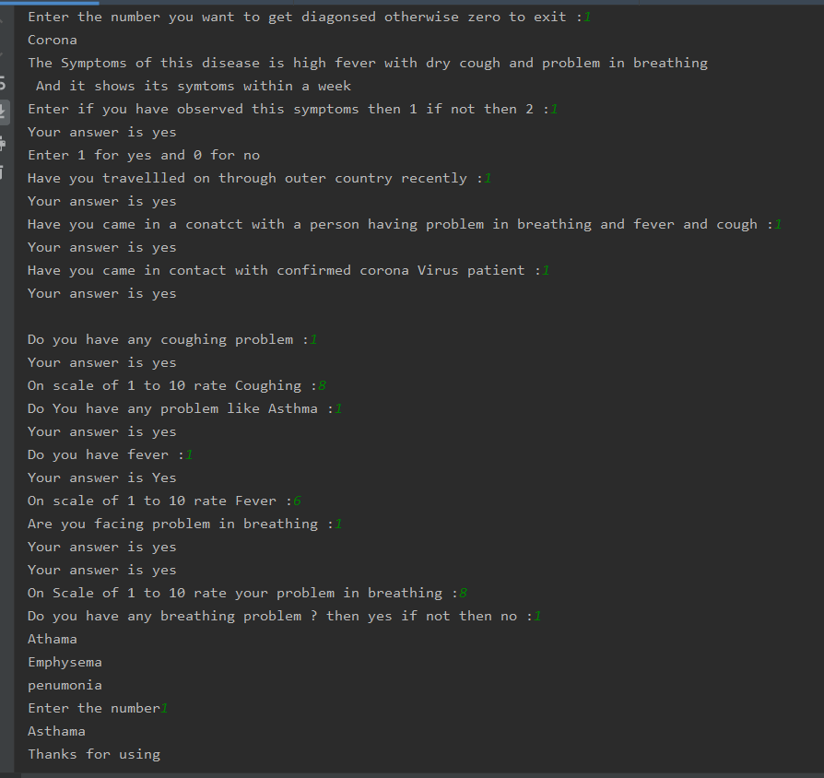

**For Asthma –**

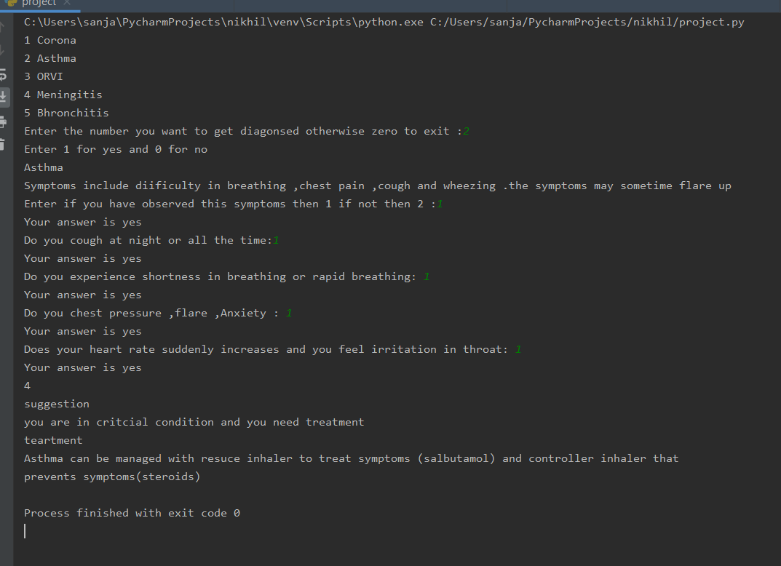

**For ORVI –**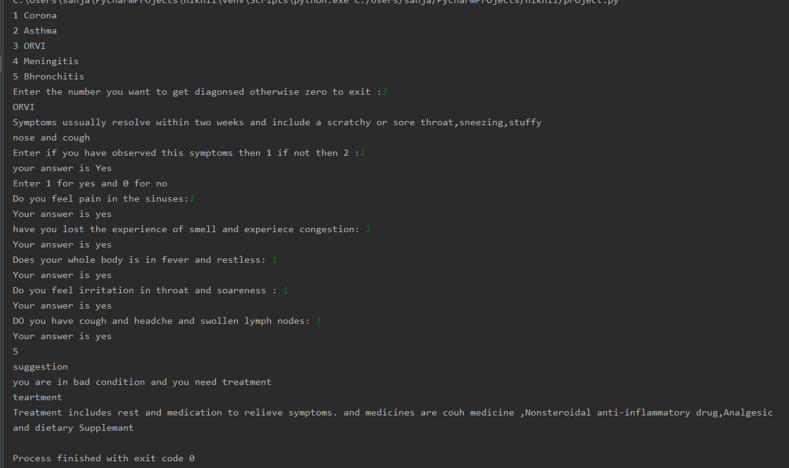

**For Meningitis –**

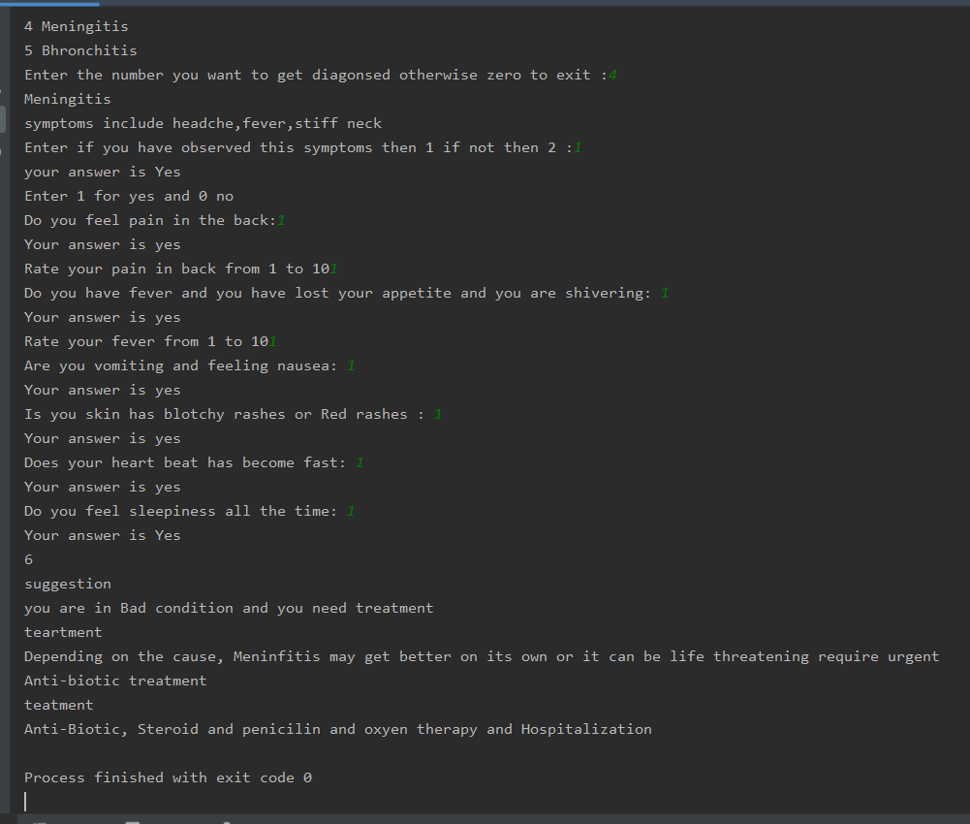

**For Bronchitis –**

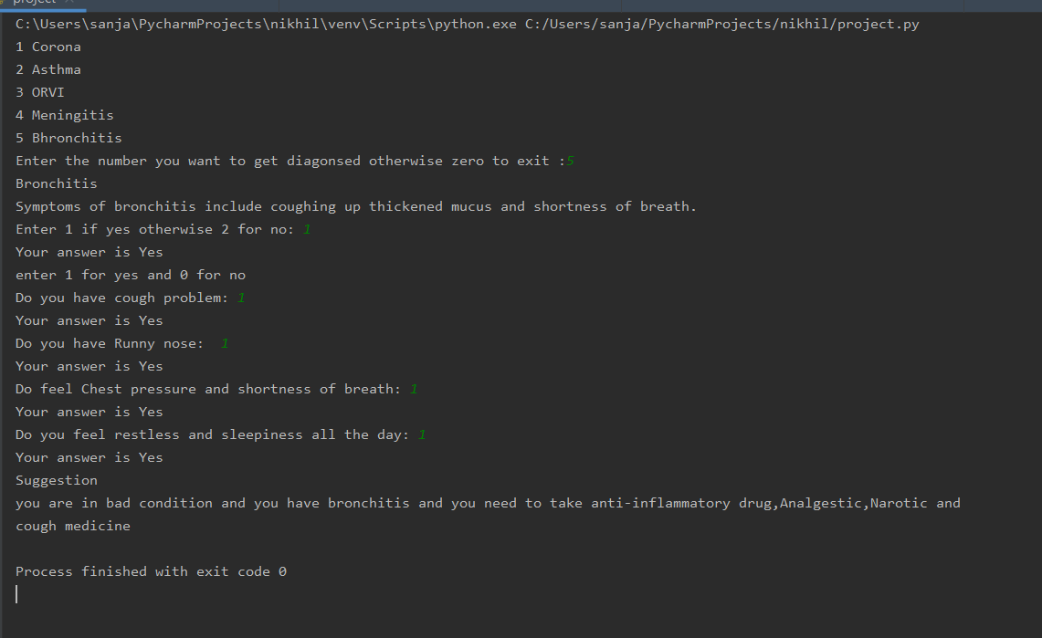**7.Flow chart –**



**8.Test cases –**

|  |  |  |  |  |  |  |
| --- | --- | --- | --- | --- | --- | --- |
| S.no | Test Case | Test Case Description | Input | Expected output | Actual output | Result |
| 1. | Diagnose choosing | In this test we will input the disease number to get diagnose | 1,2,3,4,5 | At 1 Corona  At 2 Asthma  At 3 ORVI  At 4 Meningitis  At 5 Bronchitis | At 1 corona  At 2 Asthma  At 3 ORVI  At 4 Meningitis  At 5 Bronchitis | Pass |
| 2.i | Confirmation | In this test after selecting the disease number it will show symptoms of that disease and user has to read and just to answer them in yes or no. | Input is yes | Output will be your answer is yes and it start diagnosing | Same as expected output | Pass |
| ii |  | In this test after selecting the disease number it will show symptoms of that disease and user has to read and just to answer them in yes or no. | Input is no | Output will be no, and it will get terminate | Same as expected output | pass |
| iii |  | In this test after selecting the disease number it will show symptoms of that disease and user has to read and just to answer them in yes or no. | Input is neither yes nor no | Output will be please enter a valid answer | Same as expected output | pass |
| 3. i | Symptoms confirmation | In this test we will input the answer of the questions asked by the AI | Input will be yes means 1 | It will consider the answer as yes and will show that “Your answer is yes” | Your answer is Yes | Pass |
| ii |  | In this test we will input the answer of the questions asked by the AI | Input will be no means 0. | It will consider that answer is no and show that “your answer is no” | Your answer is no | Pass |
| iii |  | In this test we will input the answer of the questions asked by the AI | Input will neither be yes nor No else it can be anything 2,3.,4…. | It will consider as any answer hence it will show that “please enter yes or no.” | Please enter yes or no only. | Pass |
| 4.i | Rate the problem | In this the user will rate his problem of coughing or fever from 0 to 10 only | Input is 9 | It will store the input value | Same as Expected output | Pass |
| Ii |  | In this the user will rate his problem of coughing or fever from 0 to 10 only | Input is 11 | It will show the message that “please input from 0 to 10 only” | Please rate it from 0 to 10 only | Pass |
| 5.i | Suggestions | In this the AI will give the suggestion according to the total number of yes if questions>=yes>=questions/2 | No input | It will say that user is in bad condition and will show suggestion and medication | Same as Expected output | Pass |
| ii |  | In this the AI will give the suggestion according to the total number of yes if questions/2>=yes>=1 | No input | It will say that your body is not showing less symptoms of that disease | Same as expected output | Pass |

**9.Conclusion – As** the first use of the Artificial intelligence is in medical field not in only diagnosing the patient other uses are also like -Monitoring heartbeat, blood pressure, Brain activities etc. So, this is

Simple AI developed using Python. Whose purpose is to diagnose the user for diseases like- Corona(epidemic), Asthma, ORVI (Respiration problem), Meningitis and Bronchitis. It only purpose to get them confirm that they are have that disease or not if yes than it will give them some suggestions and advice like -some medications. And it is developed by Roll .no -17,18,19,20 and their names are Vadlakonda Srinilaya Reddy, RAM PRAKASH, Nikhil pathak, VISHAL KUMAR RAI

**10.work-Division –**

Roll number- 17 Srinilaya work was to discuss the method that how it will work in this project.

Roll number- 18 Ram Prakash task was to make The Synopsis and final project report.

Roll number -19 Nikhil pathak task was to code the program according to the method or algorithm discussed by Srinilaya reddy and to help Vishal Rai to make the test case.

Roll number 20 Vishal kumar Rai task was to make the test case check the error on the program.

**11.References link-**

**Github link of Nikhil pathak :-**